# FRONT END

ENGINEERING-1 PROJECT

Faculty Coordinator: Niharika Thakur

## TEAM DETAIL

## Gaurav Thakur (2310990335)

Gautam Jain (2310990336) [LEADER]

Gopesh Goyal (2310990337)

## TABLE OF CONTENT

1. Introduction
2. Problem Statement
3. Technical Details
4. Key Features
5. Project highlight
6. Conclusion
7. Reference Link

# INTRODUCTION

Title: Weather Forecast website

THE PURPOSE OF A PROJECT FOR WEATHER FORECASTING IS TO **PROVIDE ACCURATE**

AND **TIMELY INFORMATION** ABOUT CURRENT AND FUTURE **WEATHER**

**CONDITIONS.**

Project Purpose

### **ACCURACY:** PROVIDE PRECISE AND RELIABLE PREDICTIONS OF WEATHER CONDITIONS.

**SAFETY:** OFFER EARLY WARNINGS FOR SEVERE WEATHER EVENTS TO PROTECT L IVES AND PROPERT Y.

**COMMUNICATION:** EFFECTIVELY CONVEY WEATHER

### INFORMATION TO THE PUBLIC AND VARIOUS SECTORS.

Project Goal

#### C O M P L E X I T Y O F T H E AT M O S P H E R E :

W E AT H E R F O R E C A S T I N G D E A L S W I T H A H I G H LY C O M P L E X A N D D Y N A M I C AT M O S P H E R E . T H E AT M O S P H E R E I S I N F L U E N C E D B Y N U M E R O U S F A C T O R S , I N C L U D I N G T E M P E R AT U R E , P R E S S U R E , H U M I D I T Y, W I N D P AT T E R N S , A N D T H E I N T E R A C T I O N O F V A R I O U S A I R

M A S S E S . P R E D I C T I N G H O W A L L T H E S E F A C T O R S W I L L I N T E R A C T A C C U R AT E L Y C A N B E C H A L L E N G I N G .

#### L I M I T E D DATA AVA I L A B I L I T Y:

W E AT H E R F O R E C A S T S H E A V I LY R E LY O N A C C U R AT E A N D U P - TO - D AT E D ATA F R O M

V A R I O U S S O U R C E S , S U C H A S W E AT H E R S TAT I O N S , S AT E L L I T E S , A N D W E AT H E R

B A L L O O N S . G A P S I N D ATA C O L L E C T I O N , I N A C C U R AT E M E A S U R E M E N T S , O R D ATA D E L AY S C A N L E A D T O L E S S P R E C I S E F O R E C A S T S .

Problem Statement

#### M O D E L I N G E R R O R S :

N U M E R I C A L W E A T H E R P R E D I C T I O N M O D E L S A R E U S E D T O S I M U L A T E T H E B E H A V I O R O F T H E

A T M O S P H E R E . T H E S E M O D E L S H A V E L I M I T A T I O N S A N D C A N I N T R O D U C E E R R O R S , E S P E C I A L L Y I N

L O N G - R A N G E F O R E C A S T S . F I N E - T U N I N G M O D E L S T O M A T C H O B S E R V E D C O N D I T I O N S I S A N O N G O I N G C H A L L E N G E .

#### E X T R E M E W EAT H E R E V E N T ' S

P R E D I C T I N G T H E P AT H A N D I N T E N S I T Y O F E X T R E M E W E AT H E R E V E N T S L I K E

H U R R I C A N E S , T O R N A D O E S , A N D F L A S H F L O O D S C A N B E P A R T I C U L A R LY C H A L L E N G I N G

D U E T O T H E I R R A P I D D E V E L O P M E N T A N D C O M P L E X D Y N A M I C S .

Problem Statement

### .VS CODE AS A CODE EDITOR HAS BEEN USED.

1. .HTML 5 AND CSS I S USED IN THIS PROJECT.
2. .EXTERNAL CSS I S USED FOR THE EASY LEARNING OF CODE.
3. .COMPRESSED IMAGES/ FAVICON FOR THE BET TER USER INTERFERENCE

Technical Detail's

**C U R R E N T W E AT H E R D ATA :** P R O V I D E R E A L - T I M E D ATA O N C U R R E N T W E AT H E R C O N D I T I O N S , I N C L U D I N G T E M P E R AT U R E , H U M I D I T Y, W I N D S P E E D A N D

D I R E C T I O N , AT M O S P H E R I C P R E S S U R E , A N D P R E C I P I TAT I O N L E V E L S . U S E R S

S H O U L D H A V E A C C E S S T O T H E M O S T U P - TO - D AT E I N F O R M AT I O N .

**S H O R T - T E R M F O R E C A S T S :** O F F E R S H O R T - T E R M W E AT H E R F O R E C A S T S F O R T H E N E X T F E W H O U R S O R D AY S . T H I S I N C L U D E S P R E D I C T I O N S F O R

T E M P E R AT U R E C H A N G E S , P R E C I P I TAT I O N , A N D W I N D C O N D I T I O N S T O H E L P U S E R S P L A N T H E I R I M M E D I AT E A C T I V I T I E S .

Key Features:

**L O N G - T E R M F O R E C A S T S :** I N C L U D E L O N G E R - R A N G E F O R E C A S T S , T Y P I C A L LY C O V E R I N G A W E E K O R M O R E . T H E S E F O R E C A S T S G I V E U S E R S A N I D E A O F

W H AT T O E X P E C T I N T E R M S O F W E AT H E R T R E N D S , E N A B L I N G T H E M T O P L A N

VA C AT I O N S , E V E N T S , O R O U T D O O R A C T I V I T I E S .

**S E V E R E W E AT H E R A L E R T S :** I M P L E M E N T A S Y S T E M F O R I S S U I N G S E V E R E W E AT H E R A L E R T S , S U C H A S WA R N I N G S F O R H U R R I C A N E S , T O R N A D O E S ,

F L O O D S , O R E X T R E M E H E AT. U S E R S S H O U L D R E C E I V E N O T I F I C AT I O N S A B O U T P O T E N T I A L T H R E AT S I N T H E I R A R E A .

Key Features:

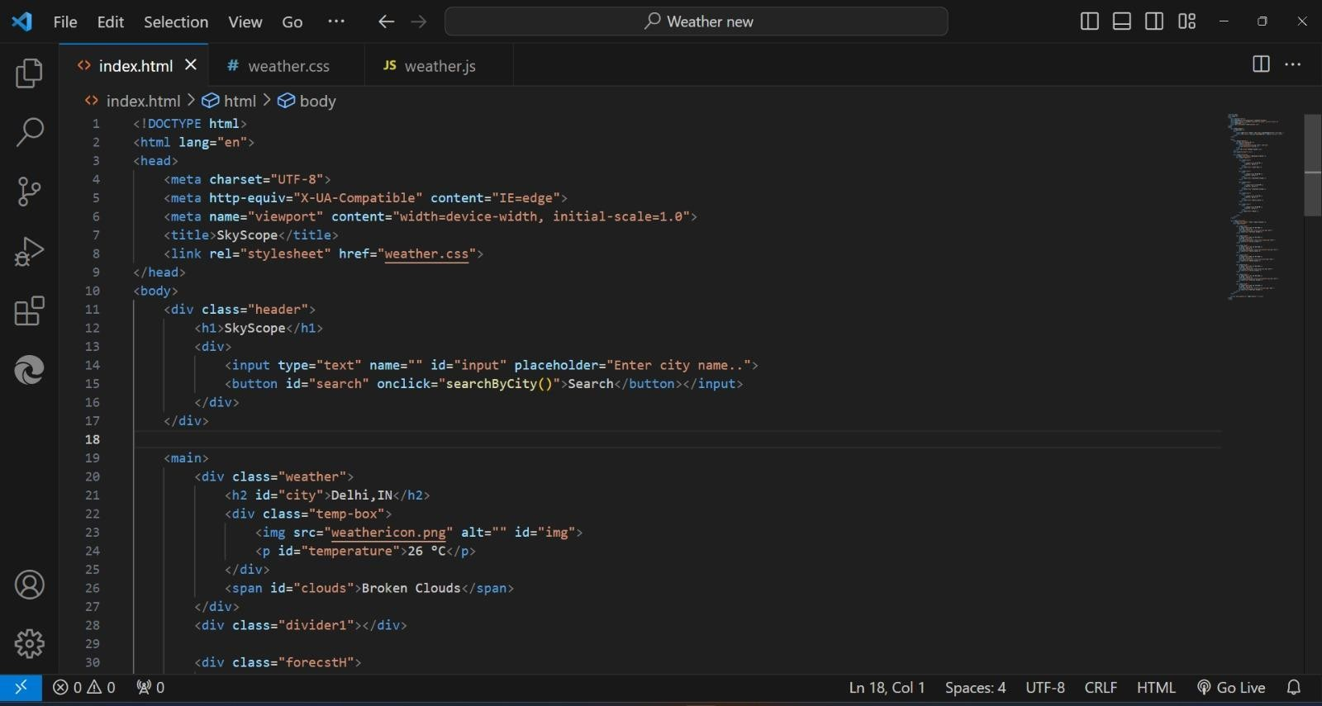

Project Highlight

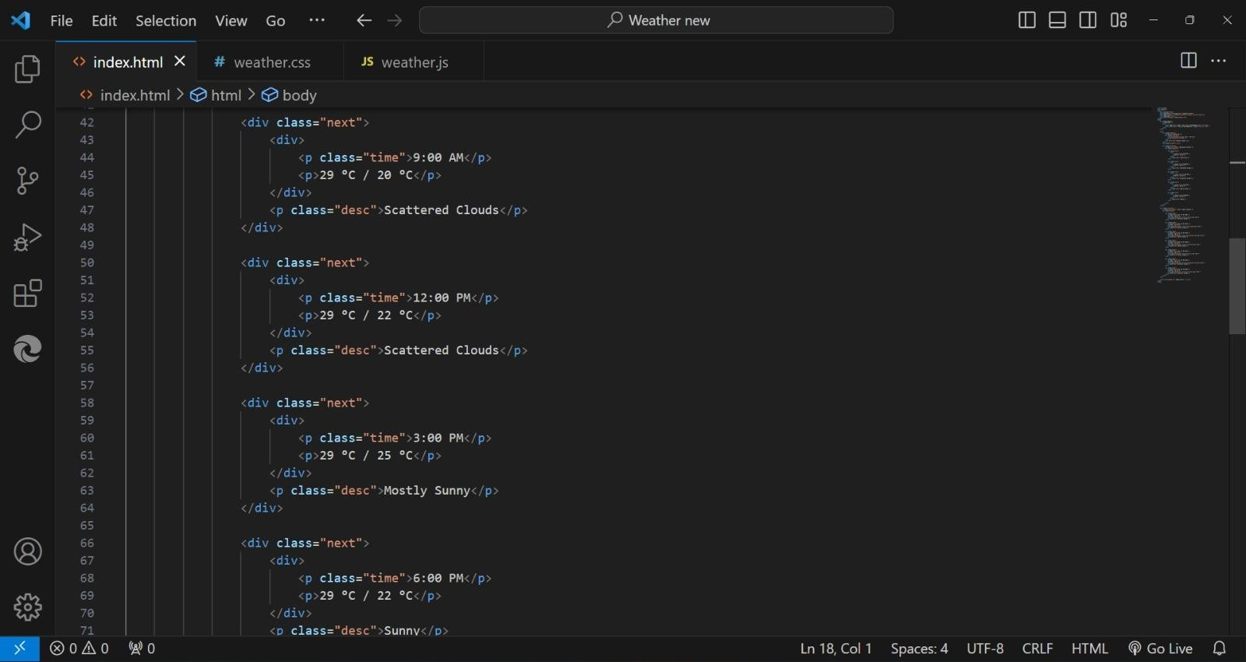

Project Highlight

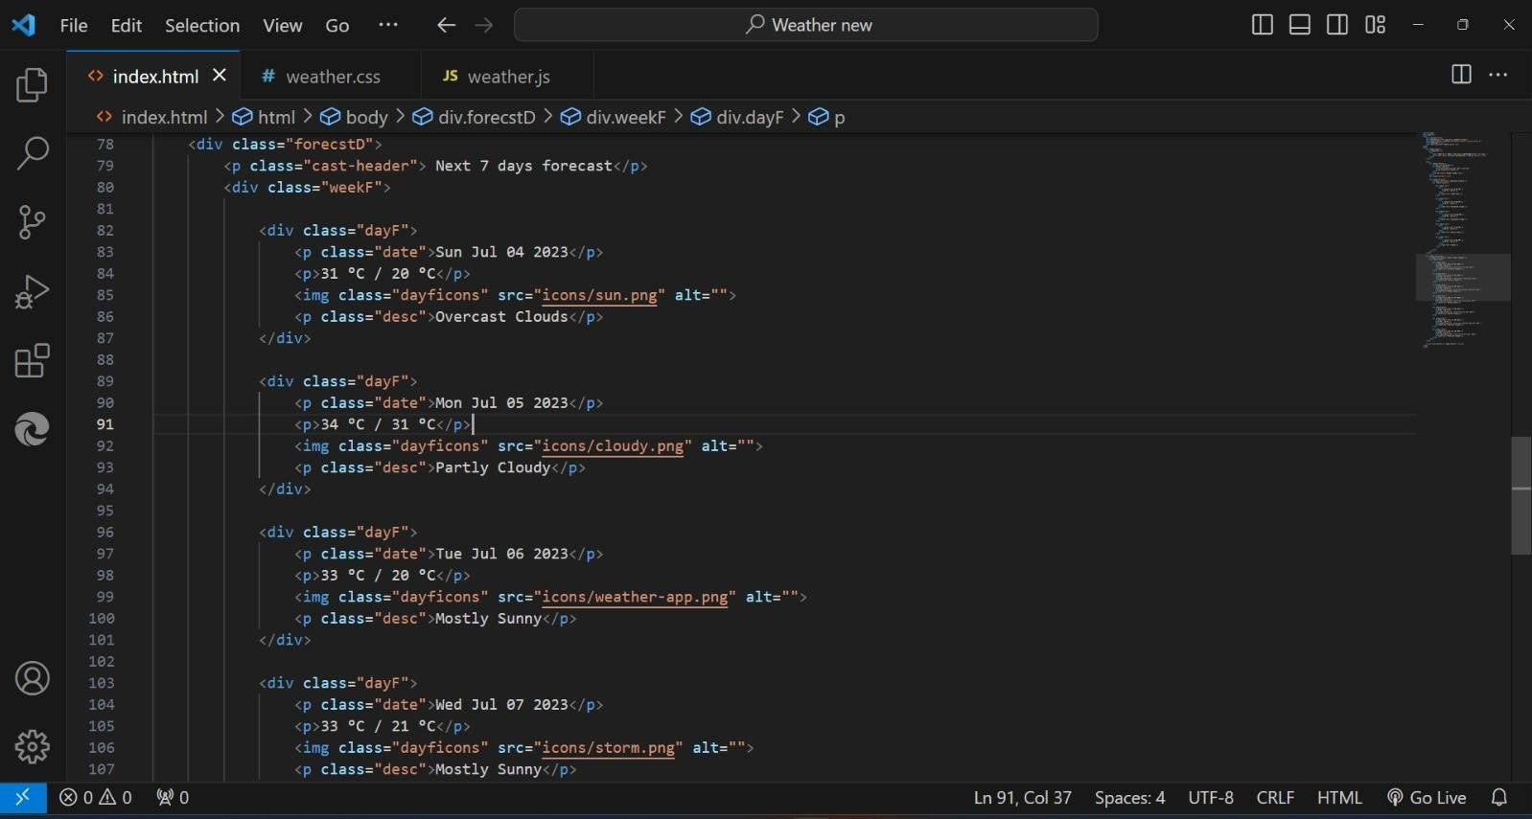

Project Highlight

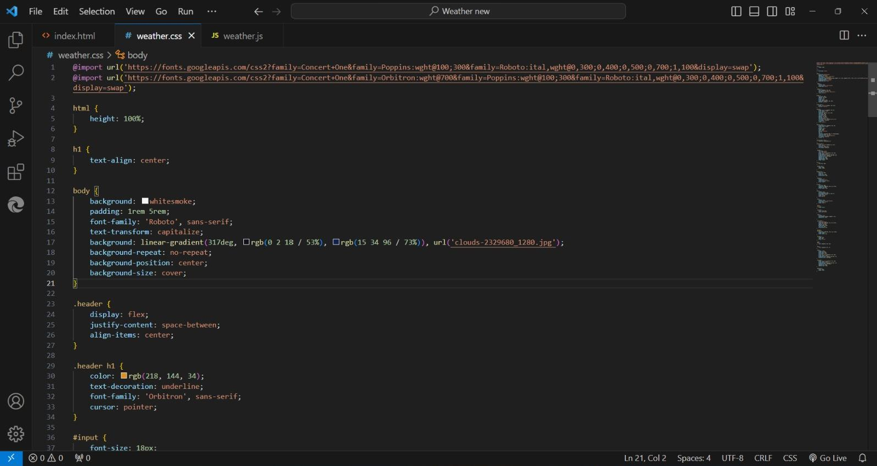

Project Highlight

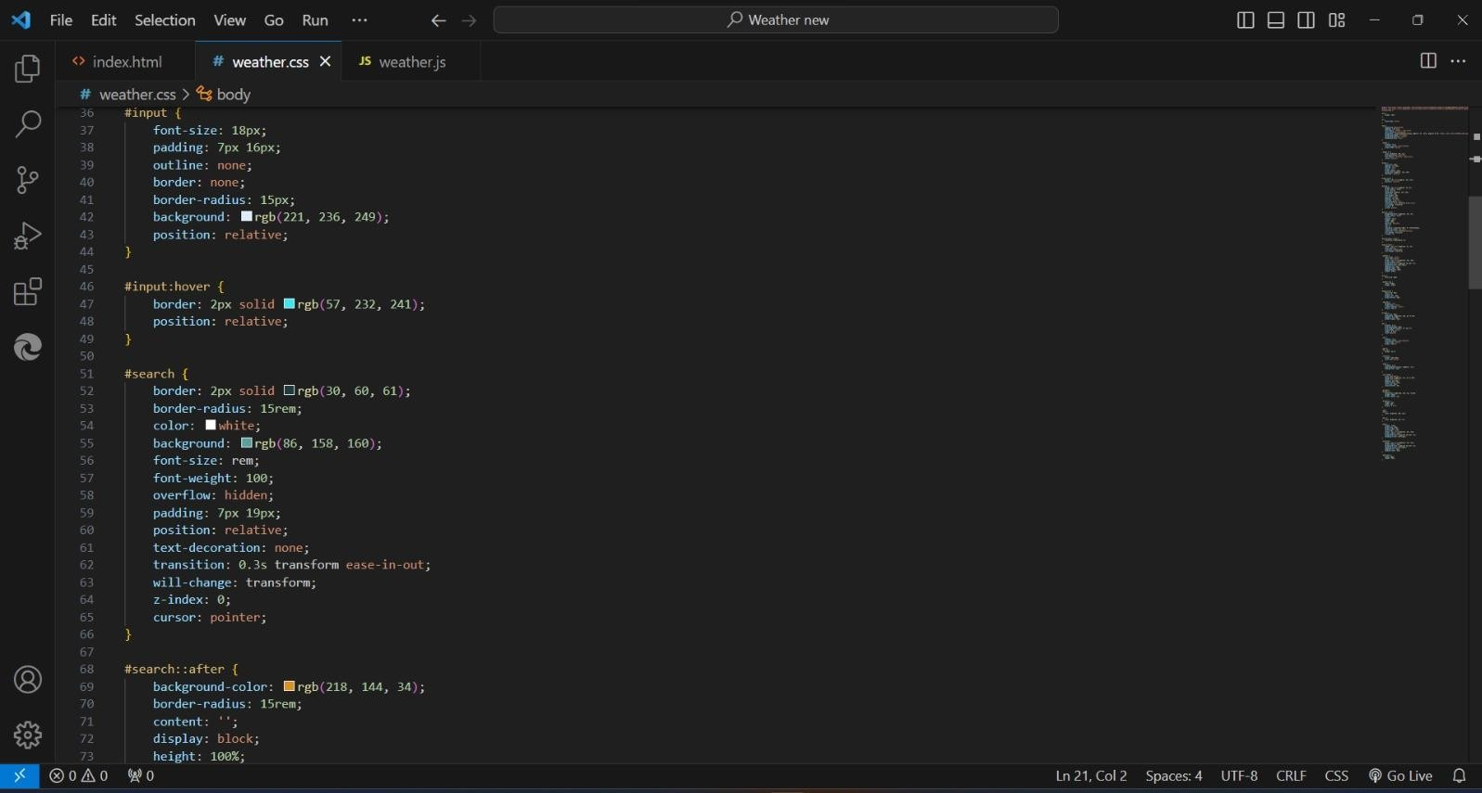

Project Highlight

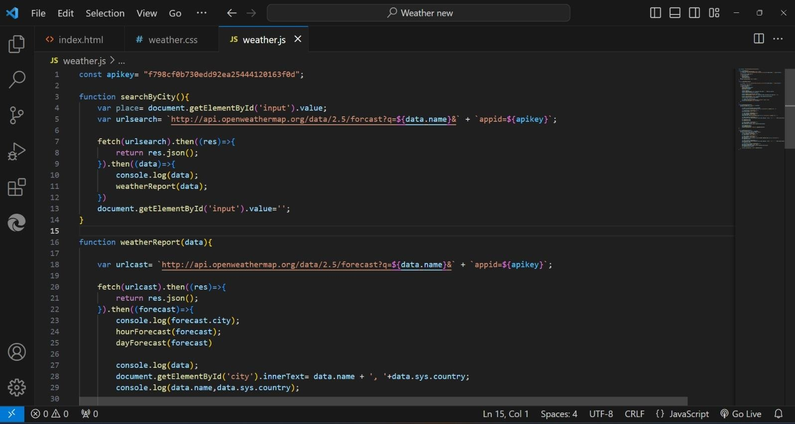

Project Highlight

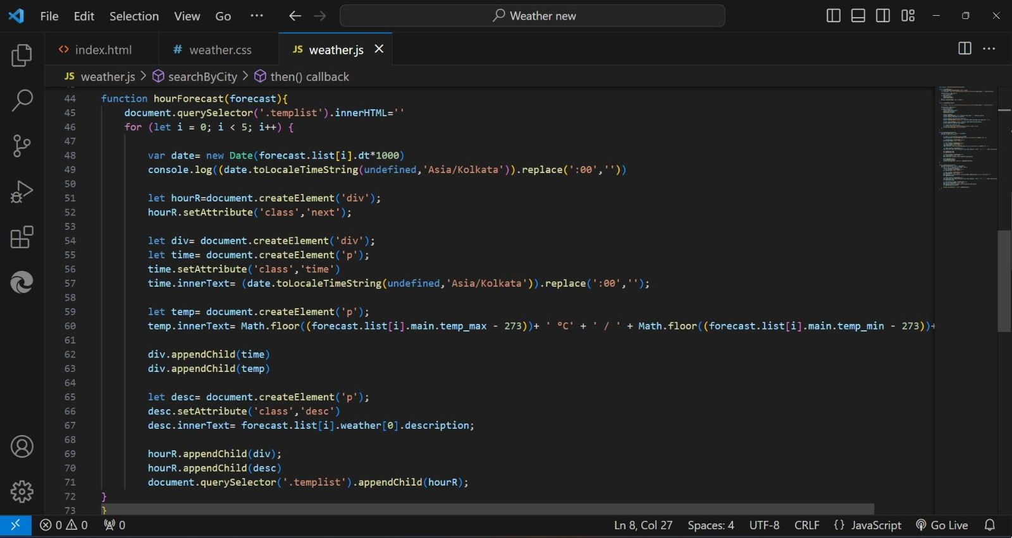

Project Highlight

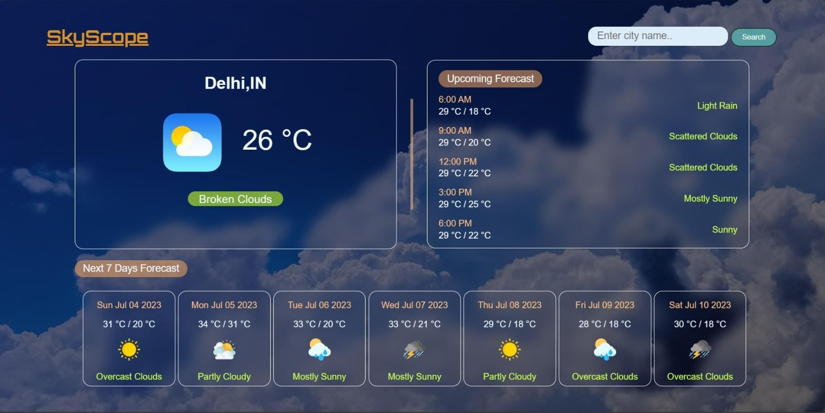

Hero Page

1. T H I S P R O J E C T I S A L L A B O U T P R O V I D I N G T H E U S E R R I G H T I N F O R M AT I O N A N D C R I T I C S A B O U T T H E V A R I O U S T O P I C S .
2. T H I S P R O J E C T D E S I R E T O I N S P I R E T H E H U M A N S F O R T H E V A R I O U S A C T I V I S M

A C T I V I T Y A N D S TA N D W I T H O R A G A I N S T T H E M A S N E E D .

1. . T H E C R E AT I V E U S E R I N T E R F E R E N C E O F T H I S W E B PA G E W I L L H E L P U S E R T O N A V I G AT E T H E M I N T O T H E D E S I R E T O P I C W I T H M O R E E A S E A N D P L E A S I N G .

Conclusion

##### . H T T P S : / / W W W. W 3 S C H O O L S . C O M /

1. . M D N . C O M
2. . H T T P S : / / W W W.Y O U T U B E . C O M /

Reference Link